22.12.18 – Final LoRa Radio test

We decided to run second test near Lake Dobczyce because of the reduced number of buildings that can cause distortions. As a transmitter we used LoRa Ra-02 module (fitted with 17 cm long antenna) with Raspberry Pi and TTGO with LoRa onboard as receiver. To enhance the signal, our base station was equipped with 15 dB Yagi antenna (without reflector, that is important when considering the results). Previous test showed that the best results can be reached when Spreading Factor is set to the value of 7 so we didn’t change it. The frequency band was equal to 433 MHz. We wanted to observe how radio communication changes when the distance between transmitter and receiver increases so we were driving along the lake shore to find some places where we can stop and check all parameters.
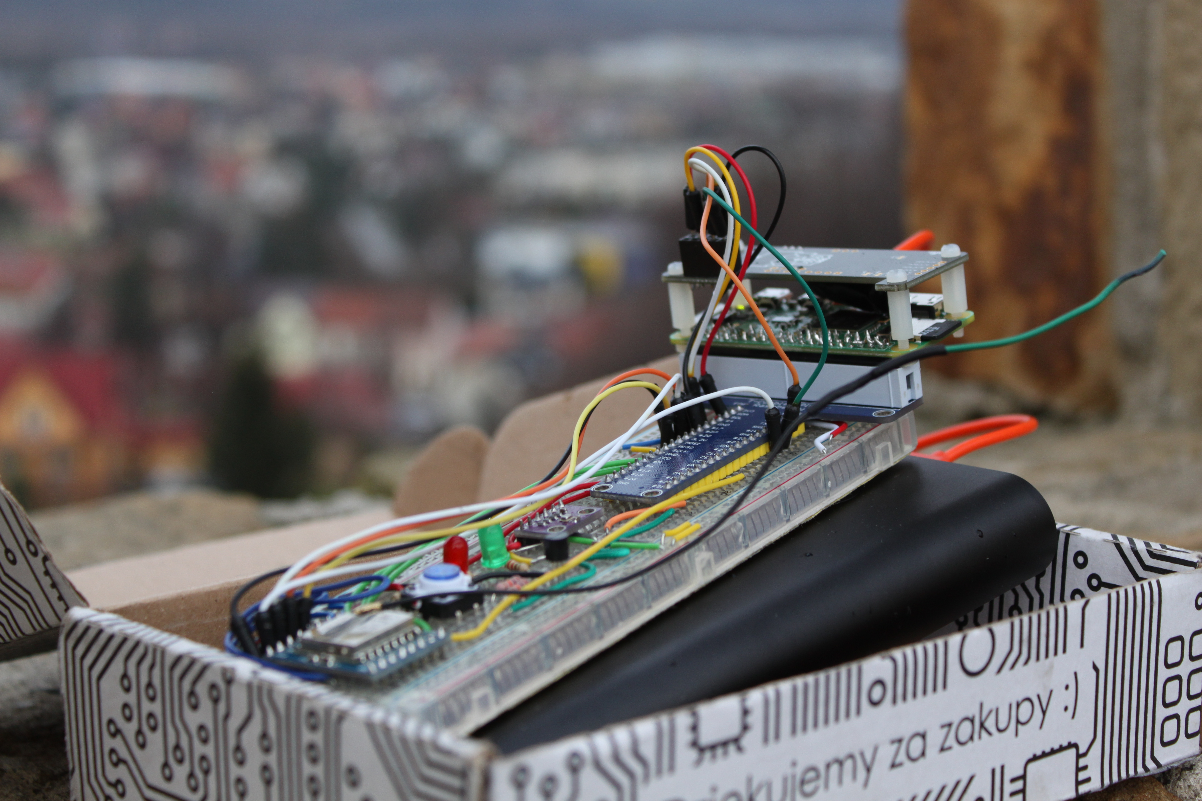

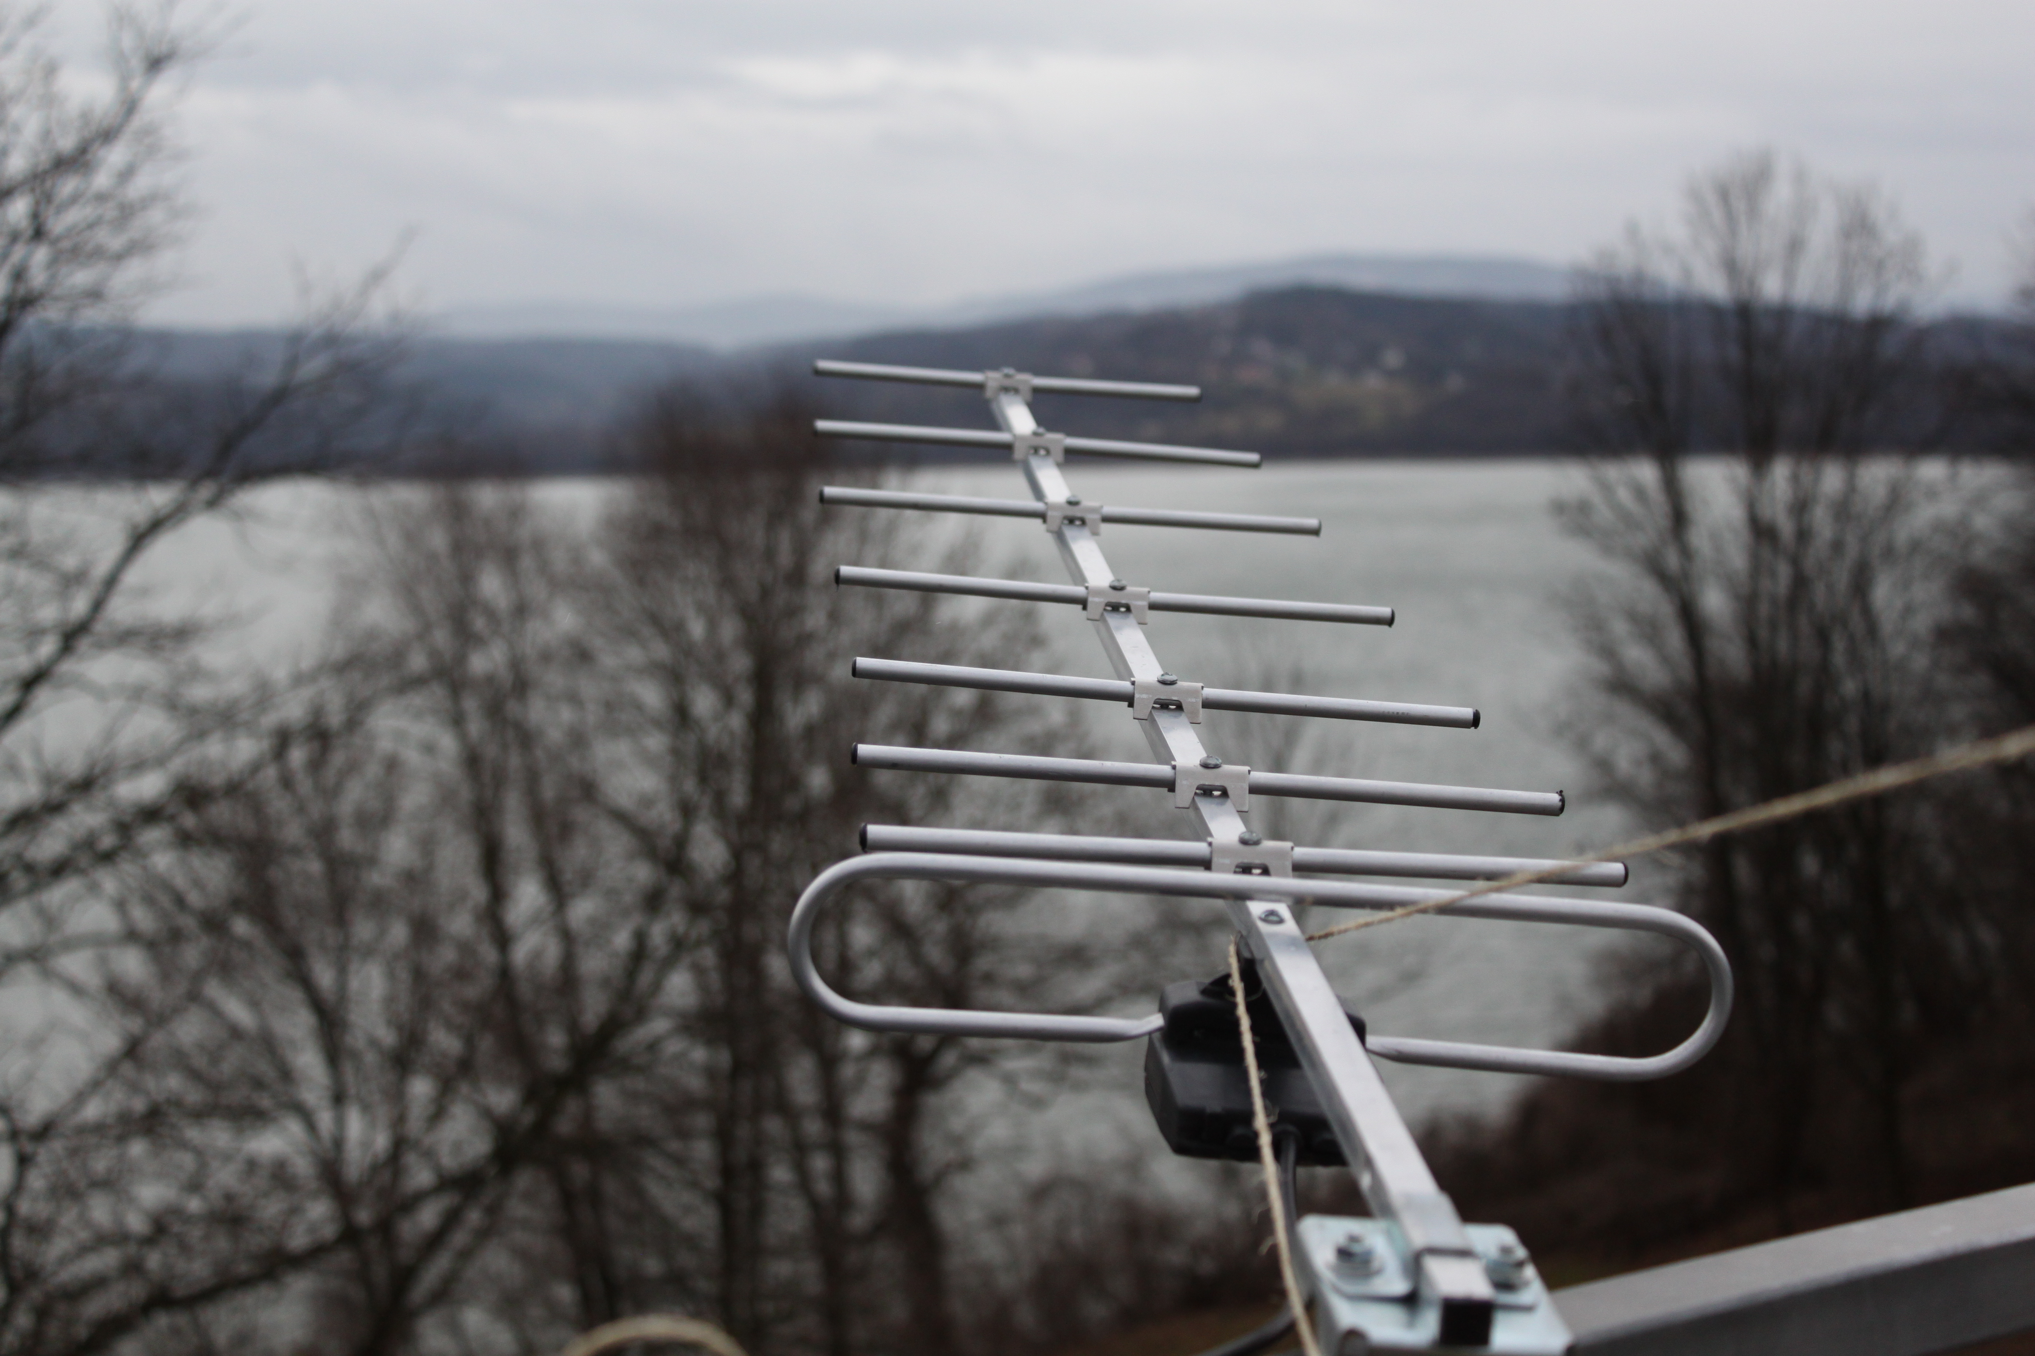

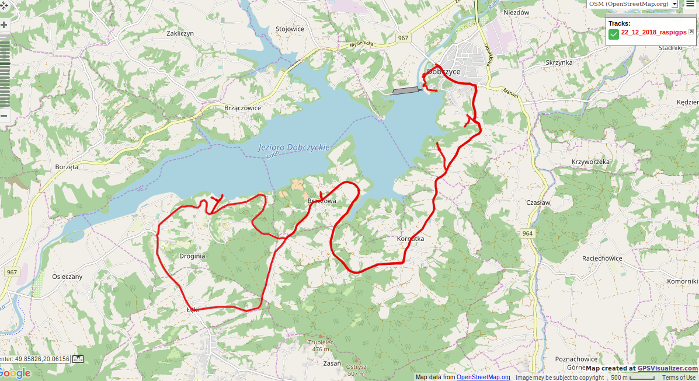

About packets
The packets were composed of an ID number and limited number of characters (it will represent all information we want to receive from our can during its final descent). Although at the base station this length was equal to 20, we decided to limit it to 10 characters when we left the station. The transmitter was set to send the packets once per 500 ms. During the finals, we are to receive sensors’ readings at least once per second so our test gave us reasonable assurance that we can do it successfully even more often.

Base Station
It was located on a vantage point on a hill near Lake Dobczyce so the total elevation above sea level was about 300 m. As we were standing there with the transmitter, an average value of RSSI was -73 dBm that is quite satisfactory result. We did some experiments with LoRa’s antenna - the chart below presents how RSSI was changing when we disconnected the antenna.

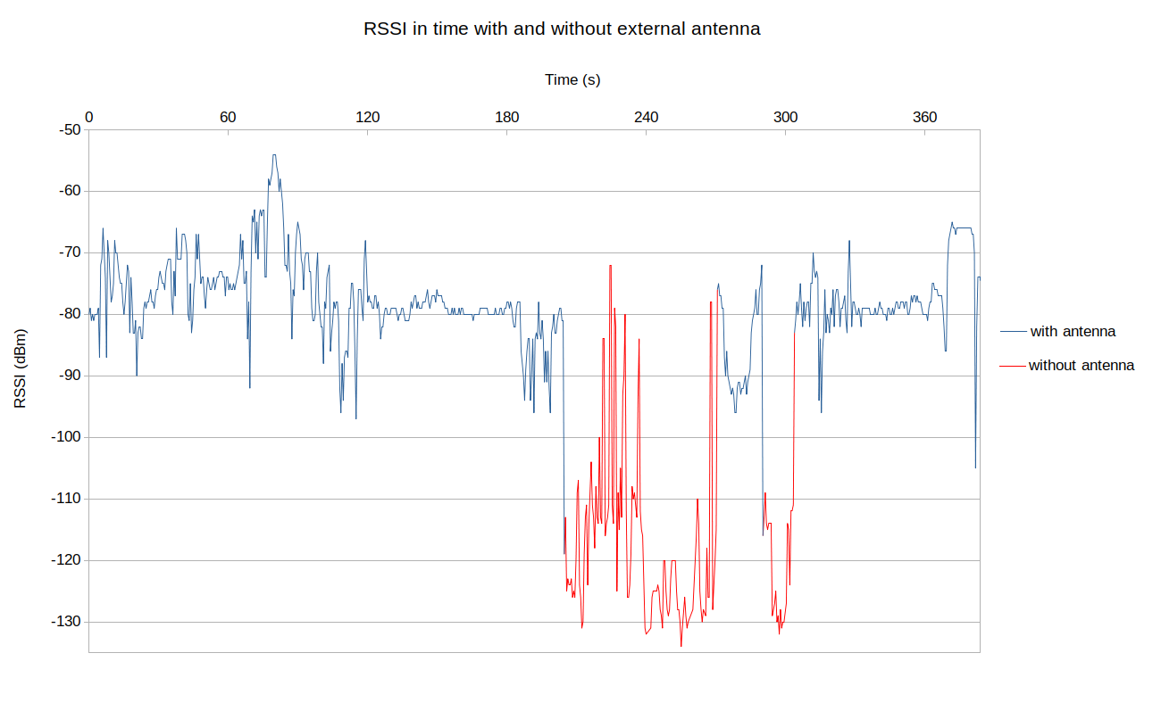

All sent packets were received when we were at base station. Then we started moving away from the vantage point where TTGO was situated and had to walk between trees – we have lost a few packets then, but the total percentage of received packets was still around 100 %. The values of RSSI were decreasing as we were increasing the distance between the can and TTGO.
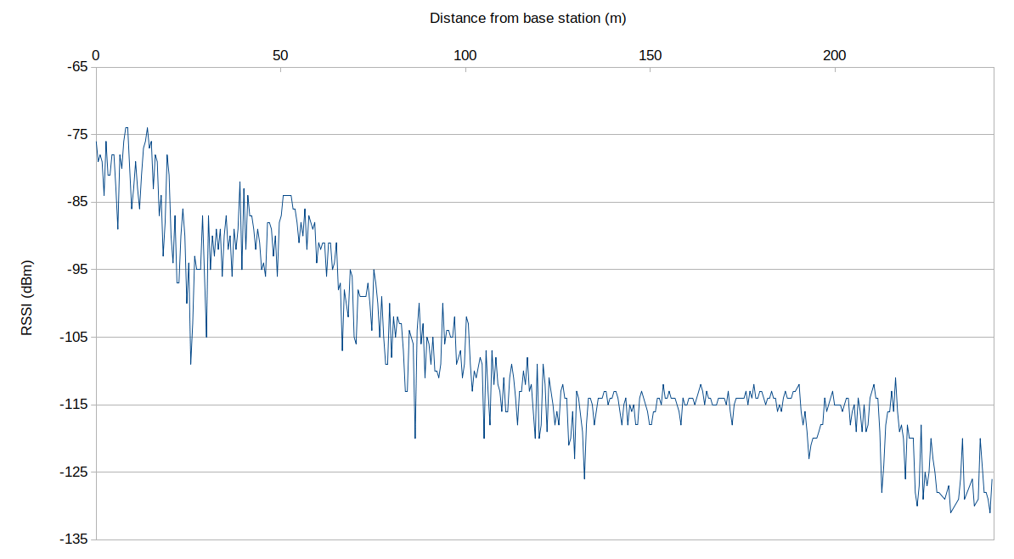

First Spot
At first we stopped about a kilometer away from base station, but unfortunately we haven’t saved any log… We thought we have, but it turned out that it was only illusion.

Second Spot
Radio frequency: 433 MHz
Spreading factor: 7
Length of a packet: 10
Distance from base station: 1.14 km
Altitude above sea level: 316 m
Percentage of received packets: 91.25 %
Packets per second: 1.82
Average RSSI: -118 dBm
Radius of the first Fresnel zone: 14.05 m
Comment: Due to the fact that the transmitter wasn’t so far from the base station, we expected that the signal strength would be better. However we should take into account that when we were holding our can, we were surrounded by trees that could cause some distortions.
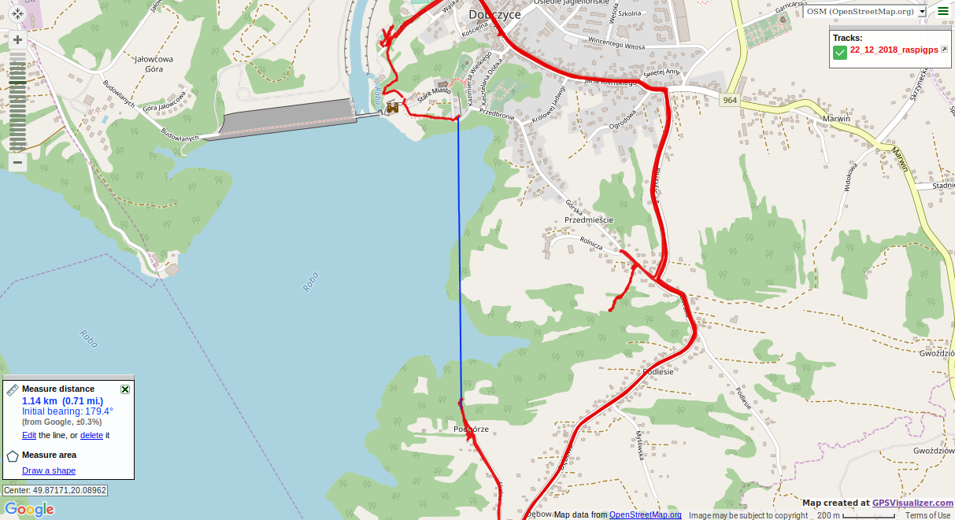

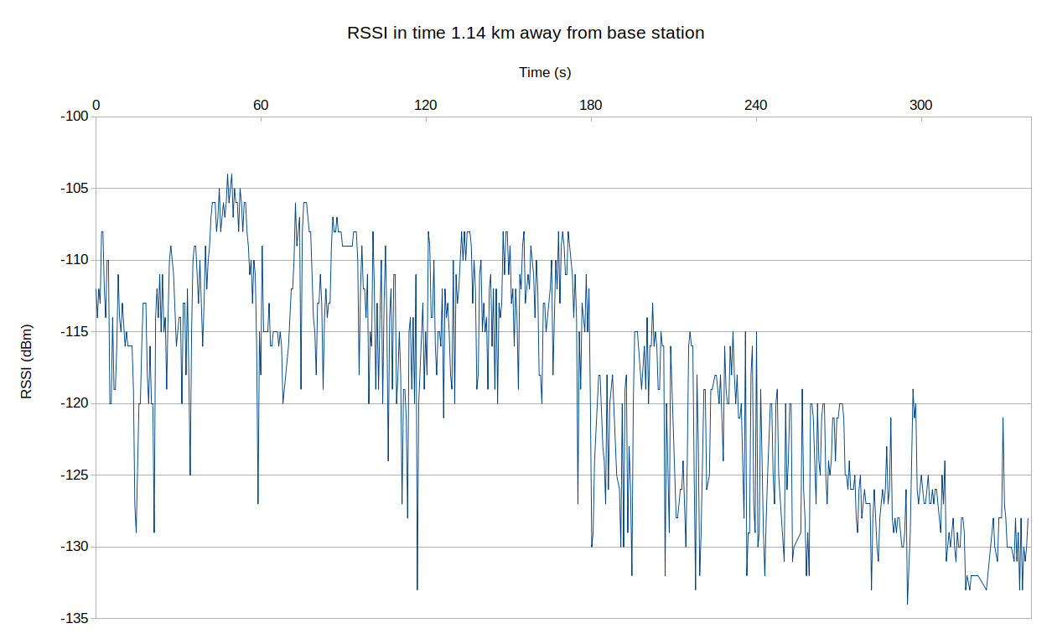

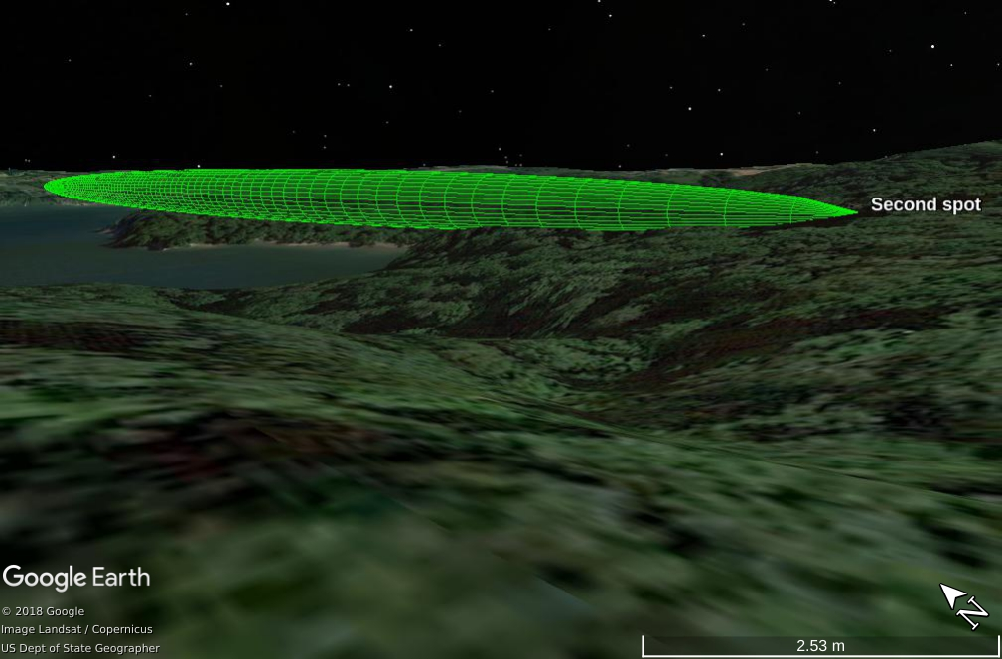
Third Spot
A visualisation of Fresnel zone
Radio frequency: 433 MHz
Spreading factor: 7
Length of a packet: 10
Distance from base station: 2.66 km
Altitude above sea level: 290 m
Percentage of received packets: 87.55 %
Packets per second: 1.74
Average RSSI: -110 dBm
Radius of the first Fresnel zone: 21.46 m
Comment: Although the results were quite good, most of the lost packets were sent in the last minute of this attempt. We suspect that we were heading back to the car then so when we were in a some kind of ravine surrounded by trees, radio communication was hindered. Assuming that we take into consideration the time without last minute (so when we probably weren’t moving through trees), the percentage of received packets is getting up to 97.35%, that gives us 1.94 packets per second!
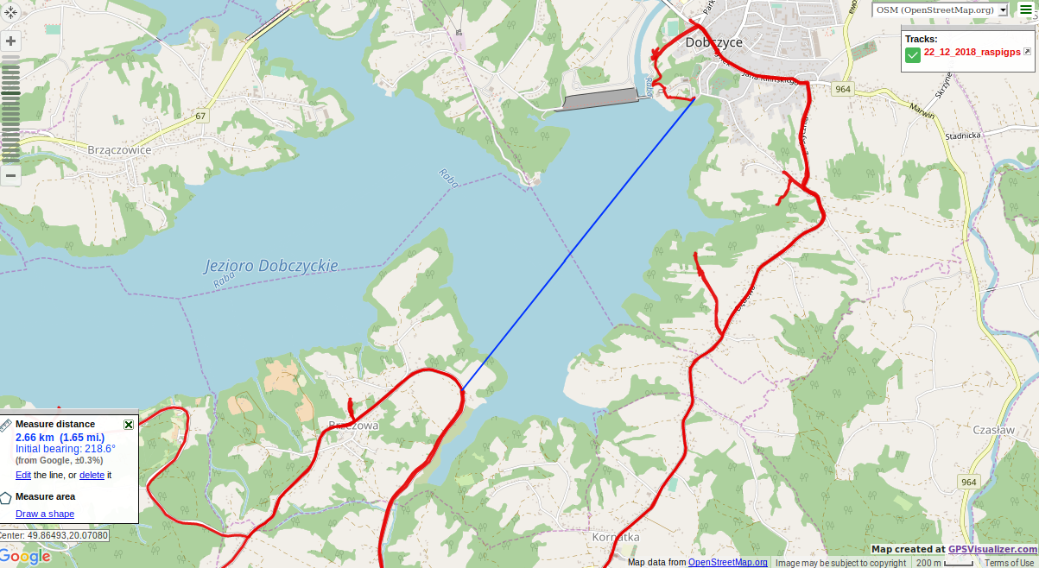
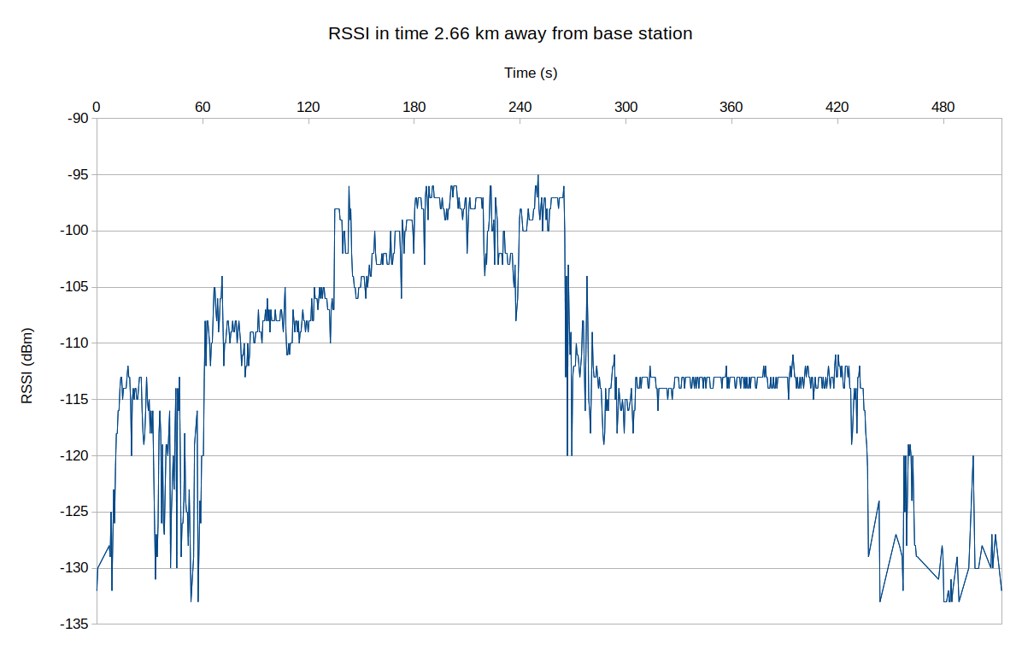
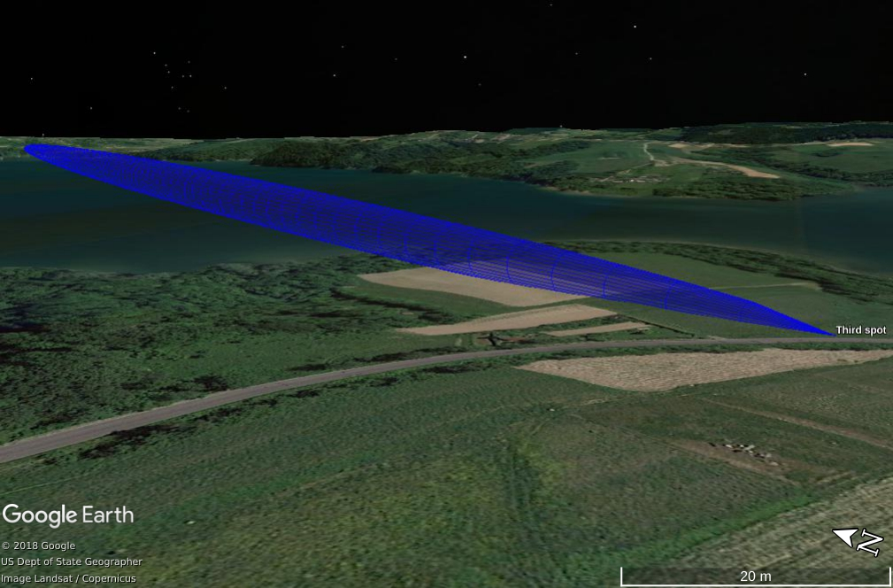
A visualisation of Fresnel zone
Fourth Spot
Radio frequency: 433 MHz
Spreading factor: 7
Length of a packet: 10
Distance from base station: 3.26 km
Altitude above sea level: 338 m
Percentage of received packets: 72.35 %
Packets per second: 1.44
Average RSSI: -121 dBm
Radius of the first Fresnel zone: 23.75 m
Comment: Low percentage of received packets was probably caused by limited amount of time we spent doing this try– all indications are that if we had stayed there longer, the results would have been better. In fact, we had arrived there earlier and when we wanted to make the first attempt, it turned out that one of our laptops at the base station was out of power. After some time we tried once again and then everything was working fine (except weather – it was cold, windy and rainy).
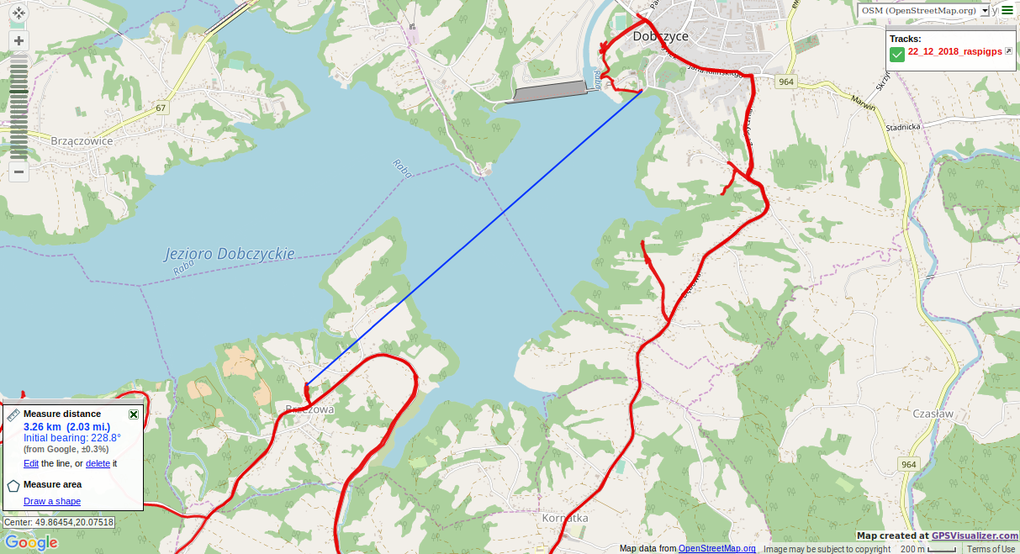
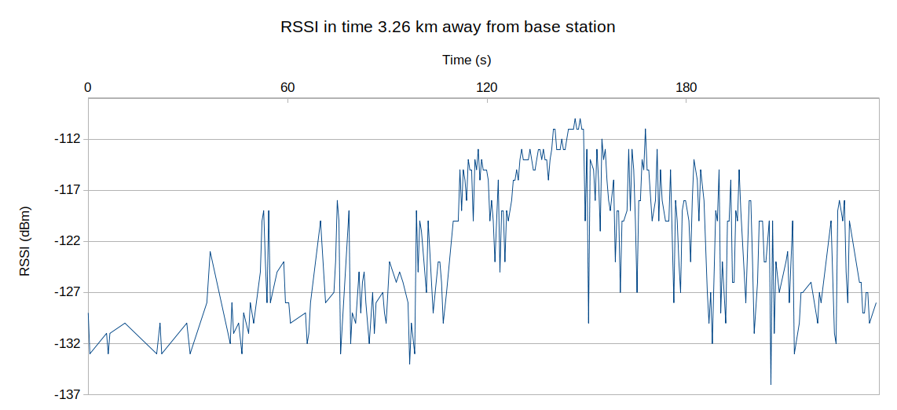
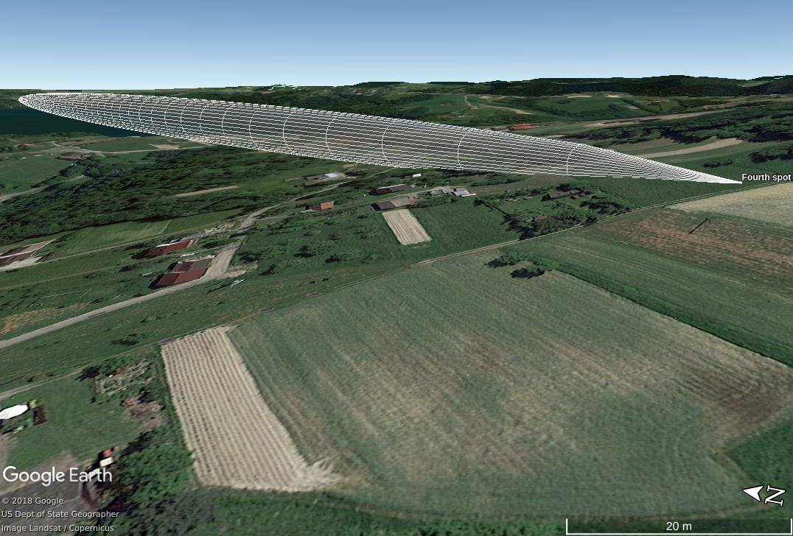
A visualisation of Fresnel zone

Fifth Spot
Radio frequency: 433 MHz
Spreading factor: 7
Length of a packet: 10
Distance from base station: 5.04 km
Altitude above sea level: 268 m
Percentage of received packets: 73.59 %
Packets per second: 1.46
Average RSSI: -124 dBm
Radius of the first Fresnel zone: 29.53 m
Comment: Thanks to reduced amount of distortions in Fresnel zone, communication between transmitter and receiver was possible even though the distance was substantial.
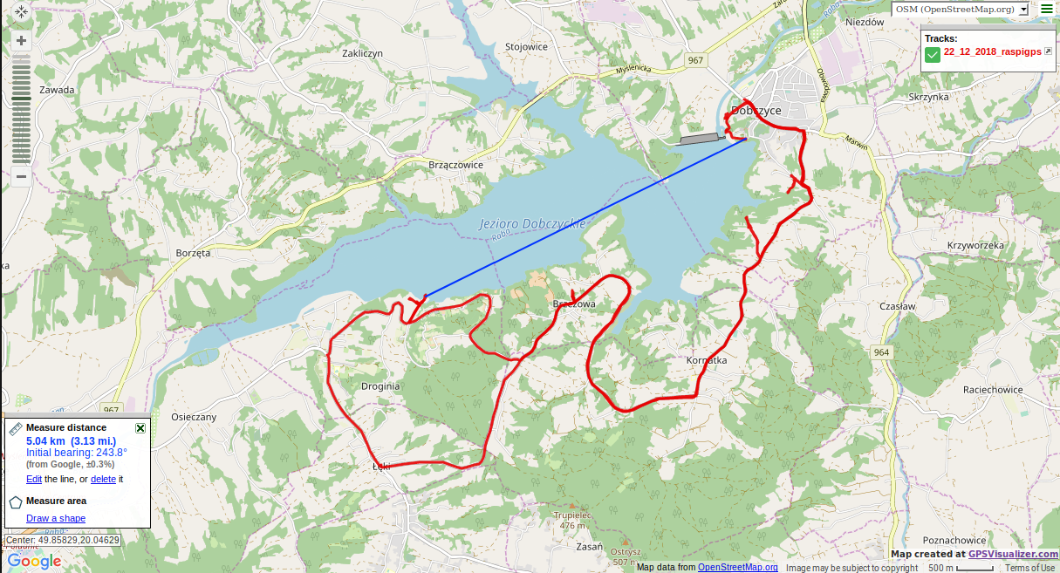
Remember: if your radio module is working as it should, do not experiment with its antenna being a few kilometers away from base station. Yes, we did it, and we lost contact for a while.

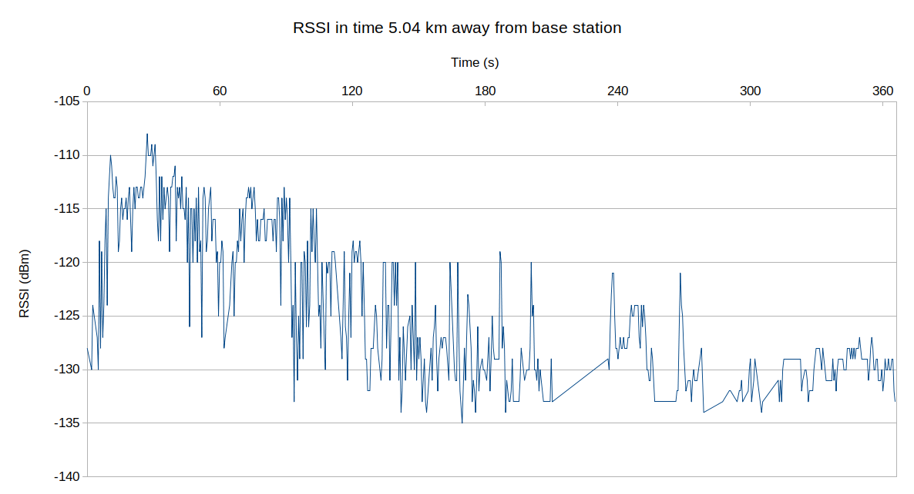

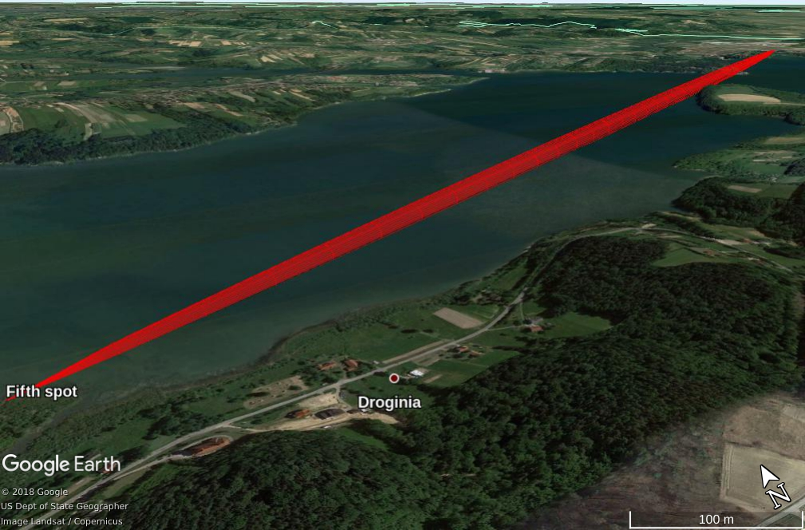
A visualisation of Fresnel zone

General conclusion:
Unfortunately the results can include some errors – although we have gathered a lot of different kinds of data and compared it, there is always a chance that the reality was a bit different from what we interpret from data. For that reason some of the results can vary up to several percent, but happily it is more likely that the results could change to our advantage (proved in the case of third spot).
At each spot we were surrounded by trees, and the terrain was hilly – these are the factors that could cause distortions, but luckily when our can will be descending, none of above will be a problem.
Moreover, we have tested the Sat in different weather conditions and now we know that neither wind nor rain would disrupt our radio communication.
We have also proved that enclosed space and velocity do not restrain radio contact completely – we received some packets even though the transmitter was inside the car! However, to make the above results more readable, we have presented the measurements we did outside the car, in relatively steady place.
And last but not least, the minimum RSSI value was really low and equal to -136 dBm!

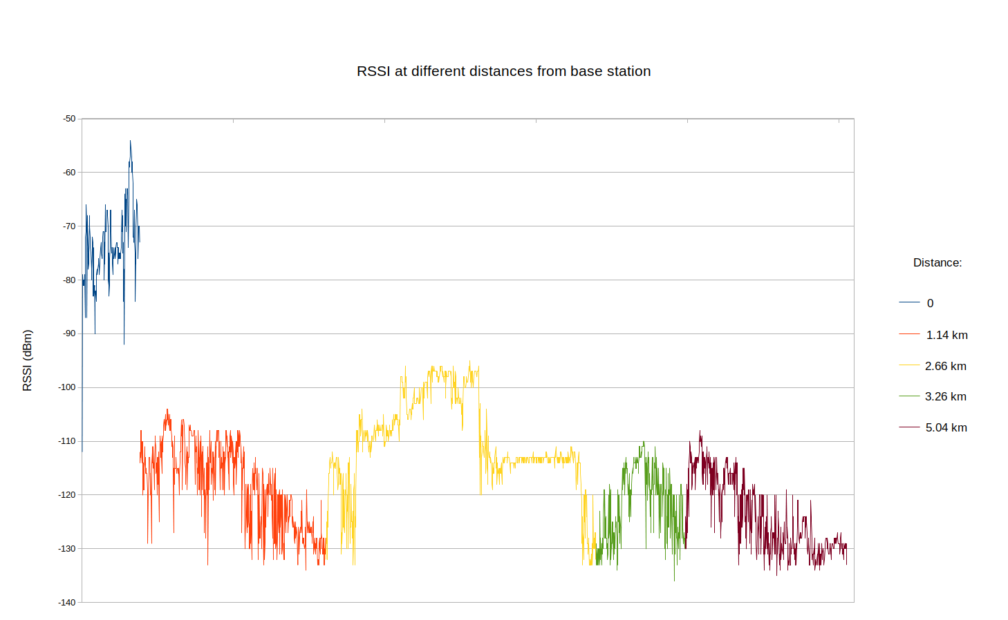

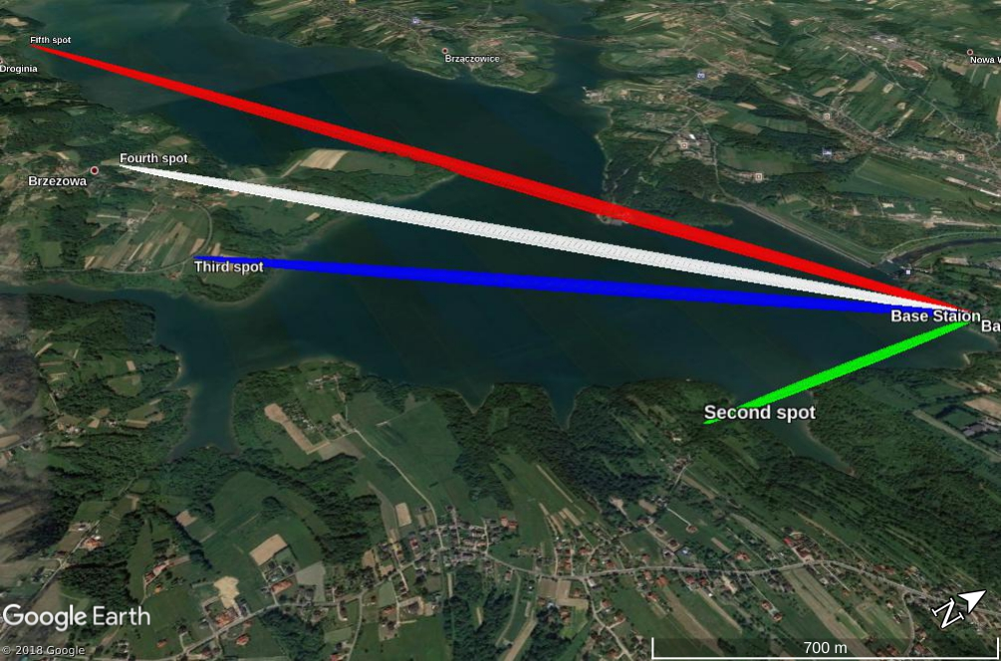
A visualisation of Fresnel zone

